Research Positioning – Summarizing Other Research
Please use the example below to fill out the chart on a few papers within your research so as to start getting an idea of what has already been done. This will help to identify the gaps in knowledge where your research can help fill.
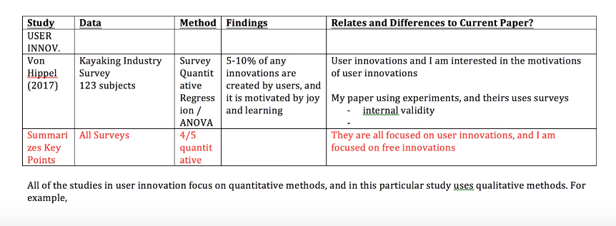
Study | Data | Method | Findings | Similarities and Difference to Current Paper

